Sound Energy
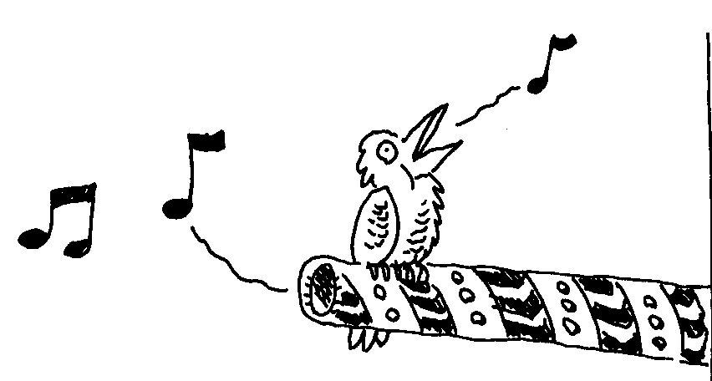
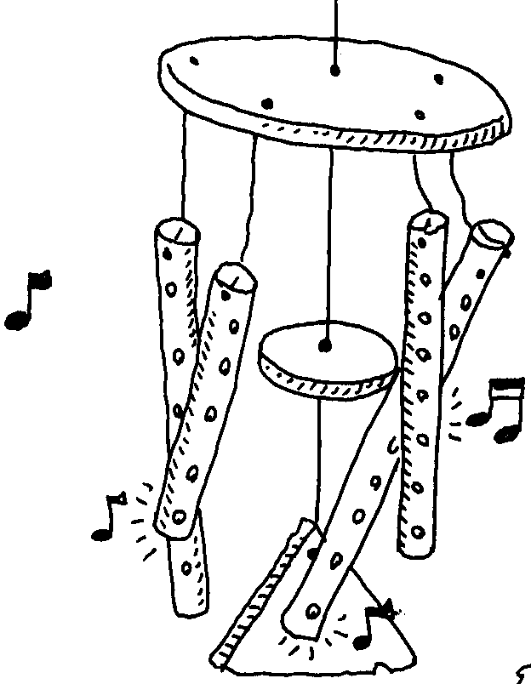

Vibrations and Pitch

Sound occurs when something vibrates. Something vibrates when it moves back and forth very quickly.

The highness or lowness of a sound is called the pitch.

1. In the following three activities, sound energy is transformed from other types of energy:
i) flicking a ruler held on the edge of a desk
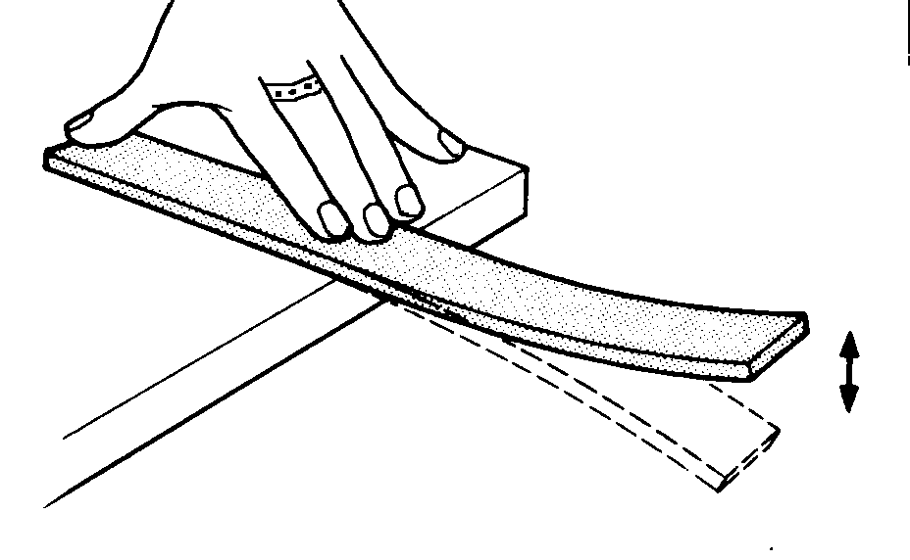
ii) gently blowing across the top of a straw
iii) gently tapping the side of a beaker with a glass rod

Experiment with sound energy in each of these three ways and then answer the following questions.
a) What is vibrating to produce the sound?
i) ii)
iii)

b) What energy transformations occurred during the production of sound in each of the three activities?
i)
ii)
iii)

c) How can you produce a sound of higher pitch in each of the three activities?
i)
ii)
iii)
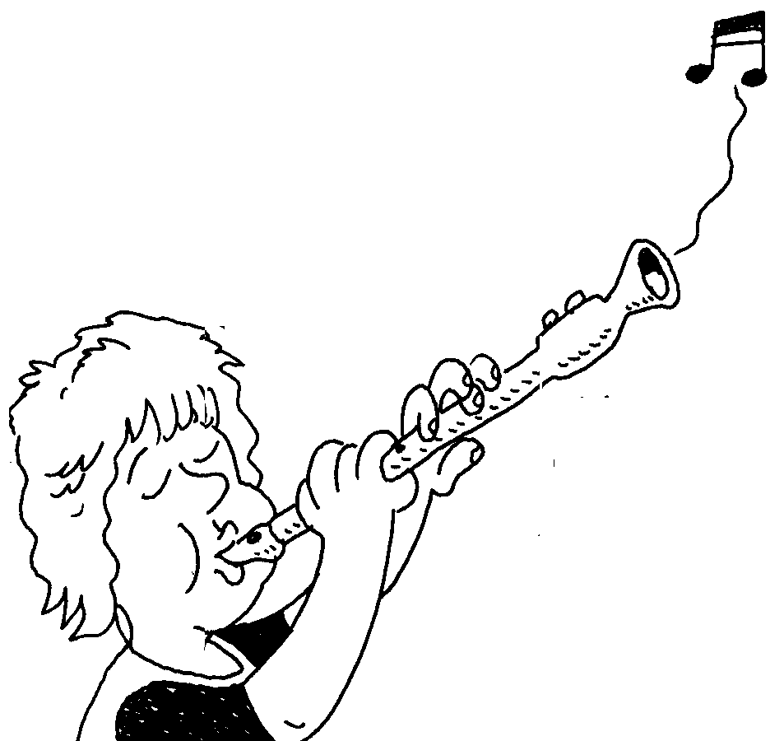
2. What feature of each of the following three musical instruments is changed to play a higher pitched note?

a) a single string of a guitar
b) a recorder
c) a xylophone

How does sound move?

If a tuning fork is struck, it vibrates. When the prongs of the fork move forward, energy is transferred from the prongs to the air particles and the particles are pushed closer together to form a patch of compressed air. Once formed, this area of compression moves through the air as the particles collide with other particles and pass their energy on. This causes a travelling vibration which is called a sound wave.

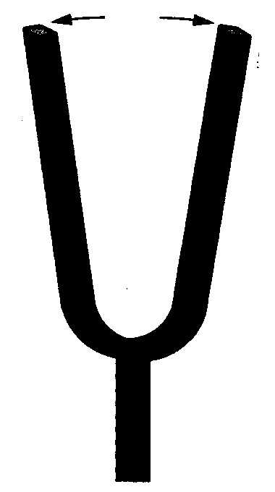
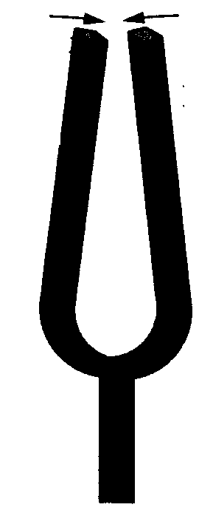

vibration through the air

When the vibrations reach the ear drum, it is made to vibrate in step with the tuning fork. The vibrating ear drum passes its energy on to smaller parts in the ear which finally results in electrical signals being transferred to the brain. The sound is then heard.
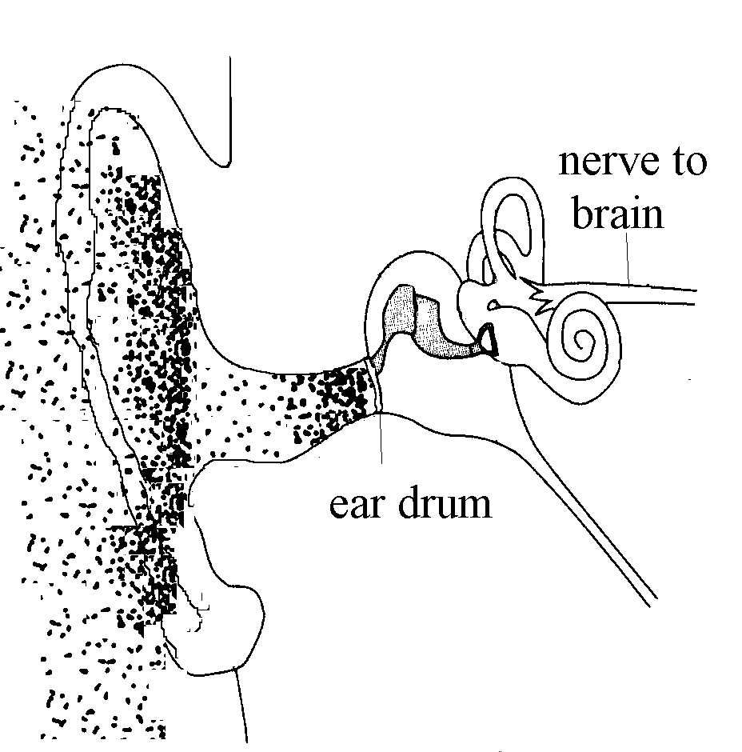


The layers of compressed air produced by a vibrating object behave rather like the coils of a "slinky" spring.

Experiment with a spring, as suggested in the following diagram, to produce compressions which move like sound energy moves through the air. Such travelling compressions are called longitudinal waves.

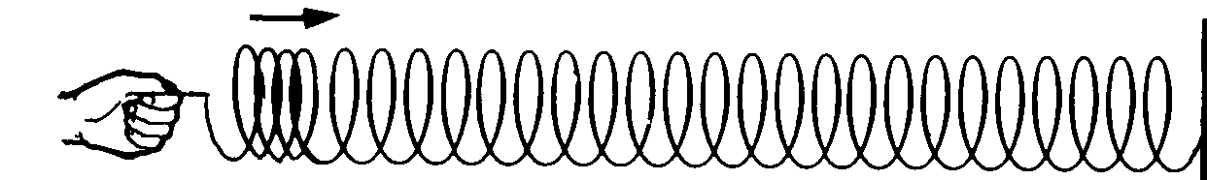
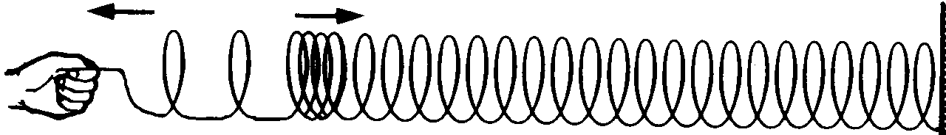

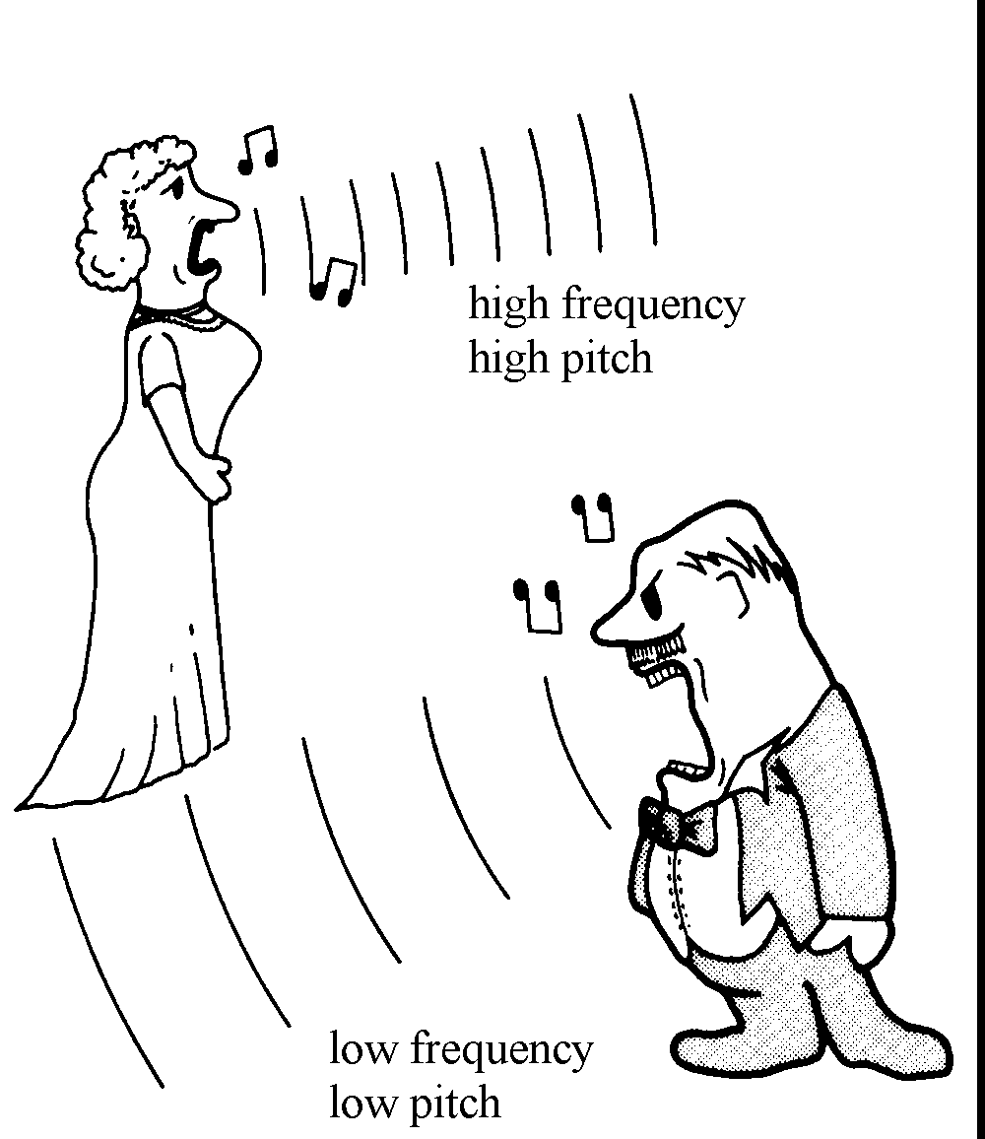
How fast sound energy is being transferred can be determined by measuring the number of vibrations produced per second. This is called the frequency of the sound wave.
The frequency of a sound wave determines the pitch of the sound. Low notes have a small frequency and high notes have large frequency.

Frequency is measured in hertz (Hz), where 1 Hz = 1 vibration per second.

3. Make models of high and low note waves with the spring.

Sketch what each spring looks like for the high note model and for the low
note model in the table on the next page. Also complete the gaps.

Pitch of note | Number of vibrations per second  (large or small?) | Frequency (low or high?) | Sketch of spring model
Low note

High note

4. Different animals can hear different frequencies of sound.
a) What frequencies of sound energy can humans hear?

b) Name several other animals which can hear different frequencies of sound energy compared to humans. Give the range of frequencies they can hear.

Echoes

5. a) What happens when the compressions in the spring reach the fixed end of the spring?
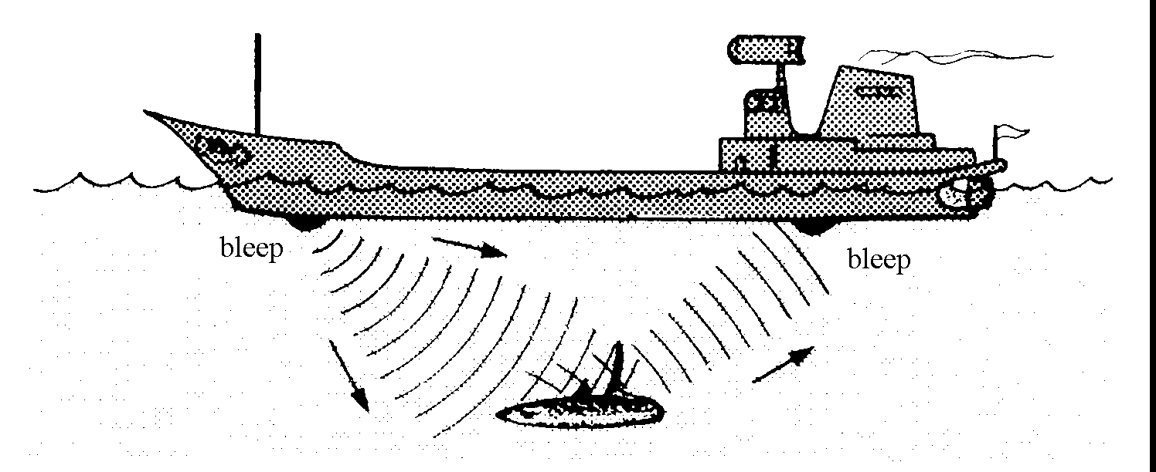

b) What scientific name is given to this behaviour?

c) What is an echo?

d) What causes an echo?

Loudness
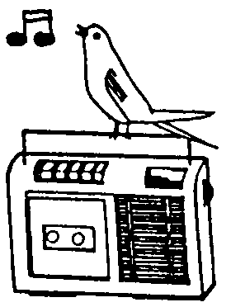

The loudness of a sound depends on how much energy goes into producing the vibration. A large amount of energy will cause a loud sound and a smaller amount of energy will cause a soft sound.

6. a) What unit is used to measure sound level (degree of loudness)?

b) Name a soft sound and a loud sound, and their respective sound levels.



c) What sound levels can damage hearing? Compare this level to that of a rock band.

What can sound travel through?
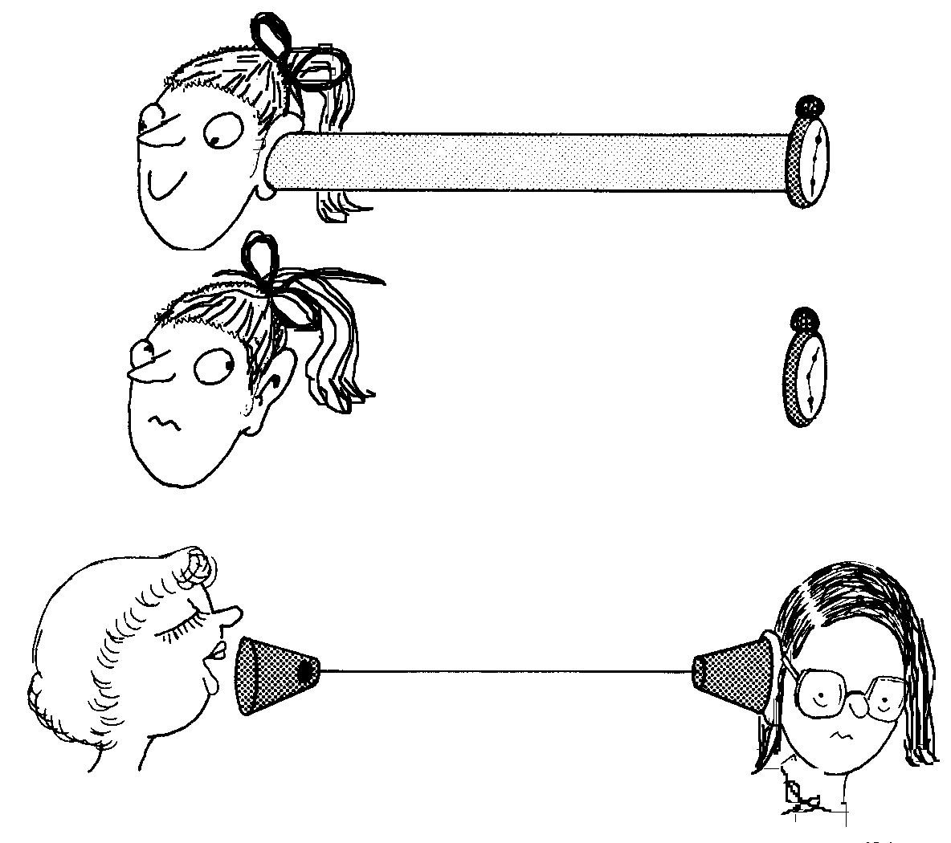

Usually sounds come to us as vibrations in the air, but we can also hear sounds that vibrate through other materials, as long as they can make our eardrums vibrate. Sound travels better through some materials than others.

7. a) Compare how well sound energy moves through solids and liquids, compared to air by carrying out the following experiments. Record your results in a table.

i) Test how well a wooden ruler and a metal rule allow sound energy to pass through them by placing them against a ticking watch and your ear.
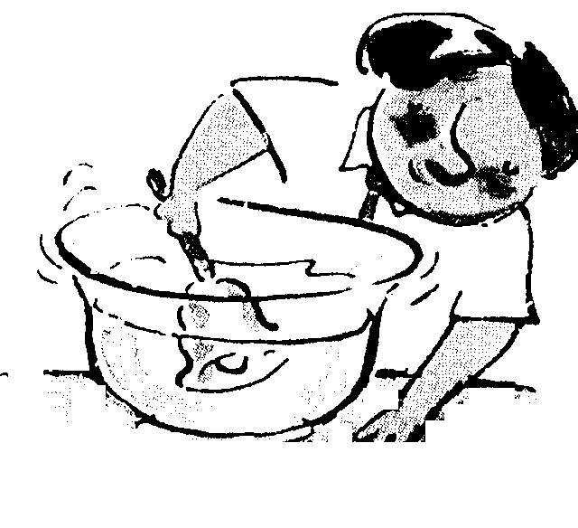

ii) Use a beaker to listen through different types of walls or a door.

iii) Use cans or plastic containers and string to make a string-can telephone.
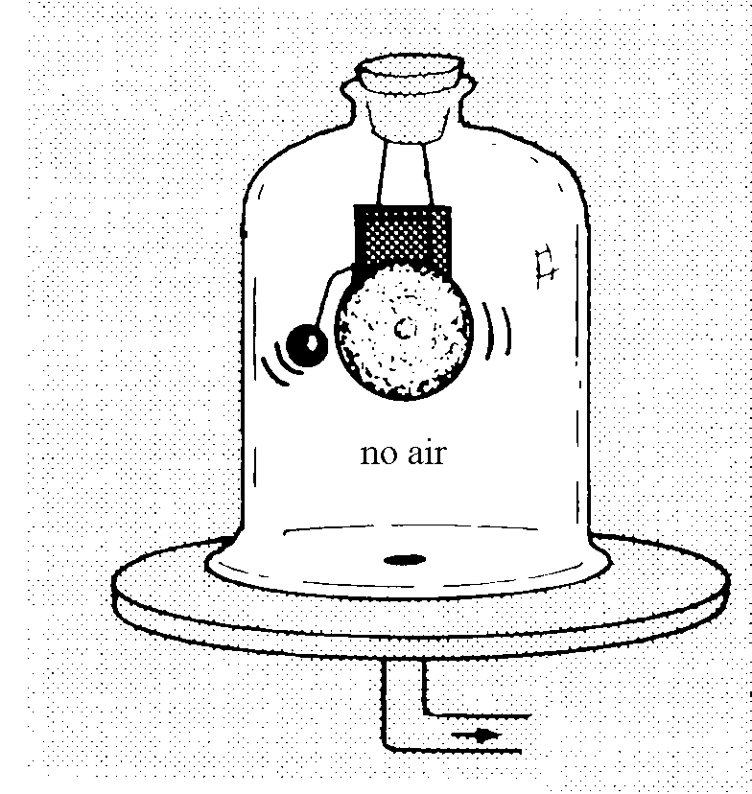

iv) Hold a bell under water and ring it.

v) Put a radio or bell in a bell jar and slowly pump the air out of the jar.

b) Attempt to explain your results to the experiments in a)



